Introduction 20090721

This document was prepared by Chris Hartley and submitted to the community by Nigel Davis. It provides a guide of the steps taken to add the MTNM/MTOSI LR model to the SID.

This document is not a formal deliverable. It provides some notes that illustrates a stage of work in progress. The document should in no way be taken as an indication that the SID will be modified in the way proposed.

The work is being tracked formally via the wiki structure in the TM Forum Community entered via http://www.tmforum.org/Community/groups/resource_management/wiki/rm-sid-mtnm-mtosi-resource-alignment-phase-1.aspx.

The document is stored in the TIP SVN repository with the model work in the RM-LR_documentation folder in the sandbox http://collab.tmforum.org/sf/scm/do/viewRepositorySource/projects.interface_program/scm.sandbox

IPR declaration

No IPR was declared by any party involved in the meetings, email exchanges or any other exchange that led to the development and generation of this document, during the production of this document itself or during any other activity related to this work that led to production of this document or during the subsequent reviews of this document.

Test of the Update Proposal

Transplant method:
- Copy MTOP NRB and NRF emx files into the SID, move into the hierarchy under LogicalResource ABE as NRB & NRF
- reparent CommonObjectInfo and CommonResorceInfo under LogicalResource
- add required external MTOP assocs.
- Move SID assocs to the old classes to the new MTOP ones
- Delete the old SID classes

The Test

Done on Keith’s sandbox copy of SID 9 at http://collab.tmforum.org/integration/viewcvs/viewcvs.cgi/keithd/?root=sandbox&system=exsy1002

Copying the classes

First need to combine Framework, NRB and NRF into a single EMX (called Combined.emx)
So that inter relationships are not corrupted
In MTOSI model, right click, create new model.

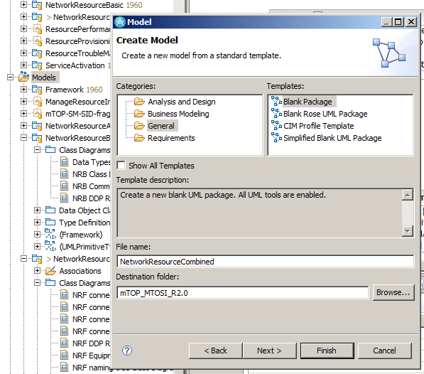

with Framework, NetworkResourceBasic and NetworkResourceFulfillment packages
Move across the artefacts to the new EMX file.
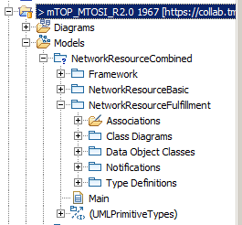

Also need to copy across !!!
NetworkResourceFulfillment::Data Object Classes::FlowDomain::ituArcStateAndStatusList

Copy Combined.emx into …\SID Phase IX Models Structure\Resource Domain

Right click on the project and refresh to show the EMX file.
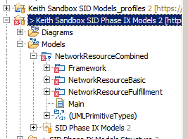

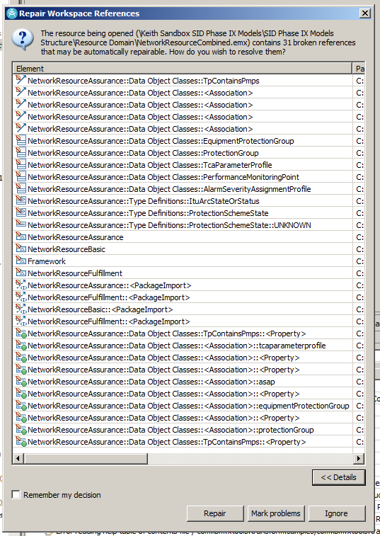

Framework, NRB and NRF artifacts moved across by dragging the three packages
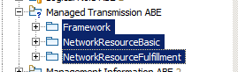

Delete the empty NetworkResourceCombined.emx from the SID.
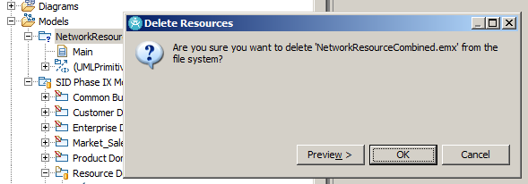

Diagram Cleanup

Remove the “From …” in diagrams by selecting classes and setting the parent style to none.

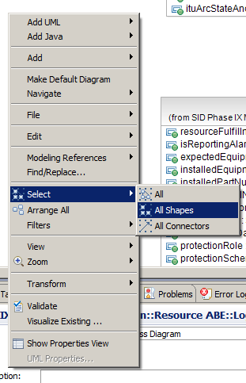

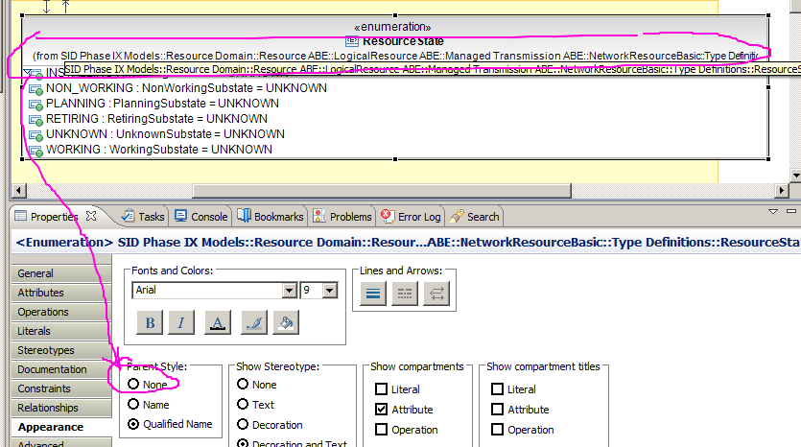

or from the menu
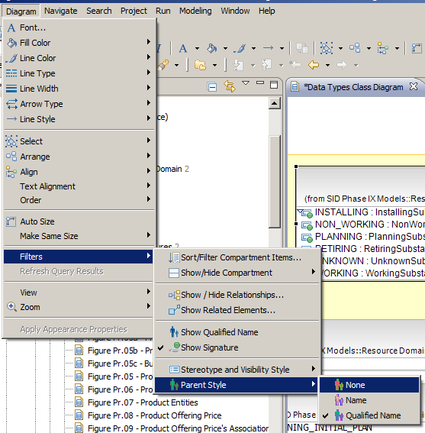

Model Fixes

Make sure you revert the MTOSI model (don’t want to commit Combined.emx)

Make the old SID classes and associations <<Deprecated>> - need this added to the Profile !!!
Do a validate and remove any unwanted broken references.
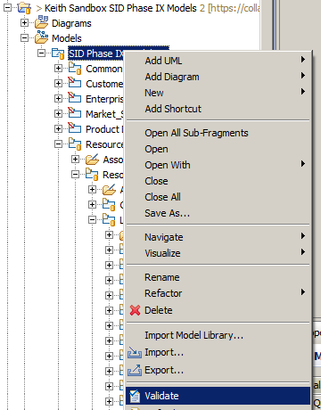

Reparent the new classes, so they are under Logical Resource. (just create a new diagram, drag on all the new classes from the explorer. Drag LogicalResource on the diagram, then just drag across the extends ends).

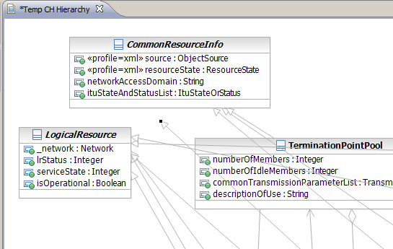

Repointer SID associations :
- Equipment (SID Equipment) – PTP
- ManagedElement (SID ManagedEntity ?) – MFD, PTP, GTP & MLS
- TPAspectCompoundResourceDetails
- PipesInSubNetwork & LogicalDeviceGovernsPipes (assume SID Pipe == MTNM TopologicalLink)
- LogicalDeviceGovernsTPs
- DeviceInterfaceTPDetails
- ManagementDomain

SID Phase IX Models::Common Business Entities Domain::Root Business Entities ABE: ManagedEntity
SID Phase IX Models::Resource Domain::Resource ABE::PhysicalResource ABE::Equipment ABE::Equipment
SID Phase IX Models::Common Business Entities Domain::Root Business Entities ABE::ManagementDomain

Delete unwanted MTNM classes
- EquipmentHolder (NRF)
- Equipment
- ManagedElement
- HolderState
- CommonObjectInfo
- CommonResourceInfo

Issues

We need to have the SID and MTOSI profiles aligned first !

